For our given TEST VECTOR:

Ukey:x”0000ee8812000043000550010022ee88”

Din:x”1234ffffffff5678”

Dout:x”1fcb2c182287a884”

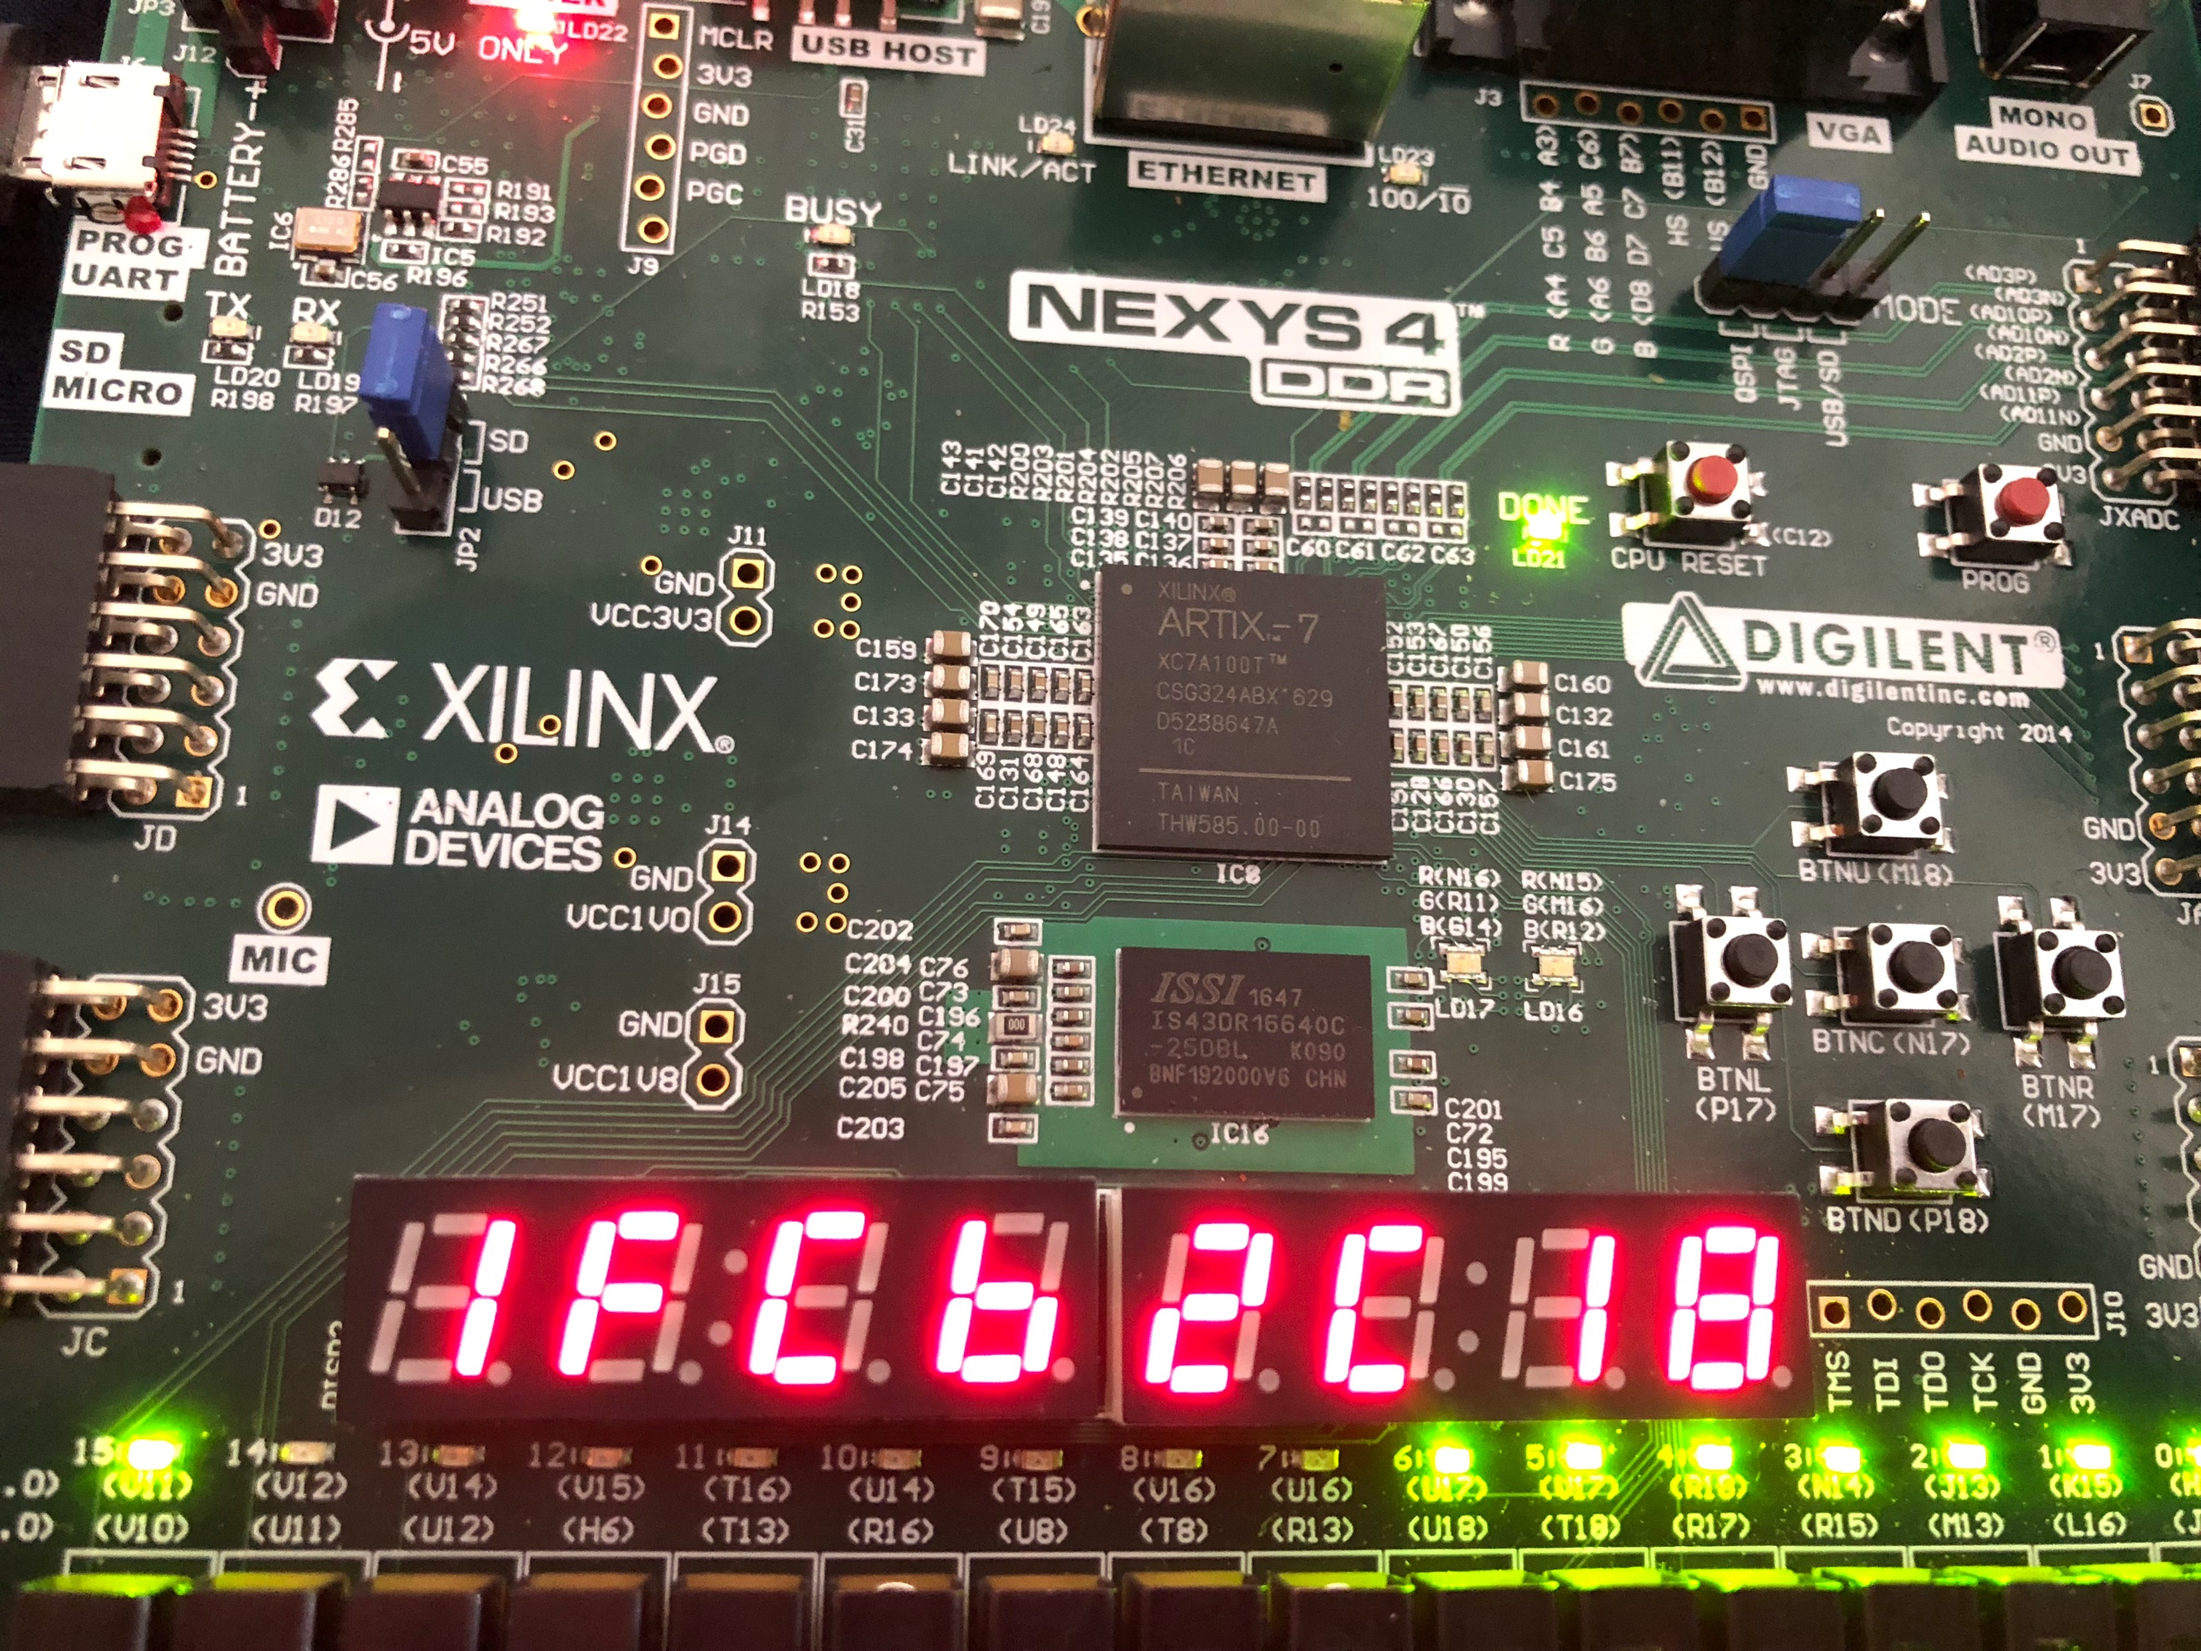

Output [63:32]

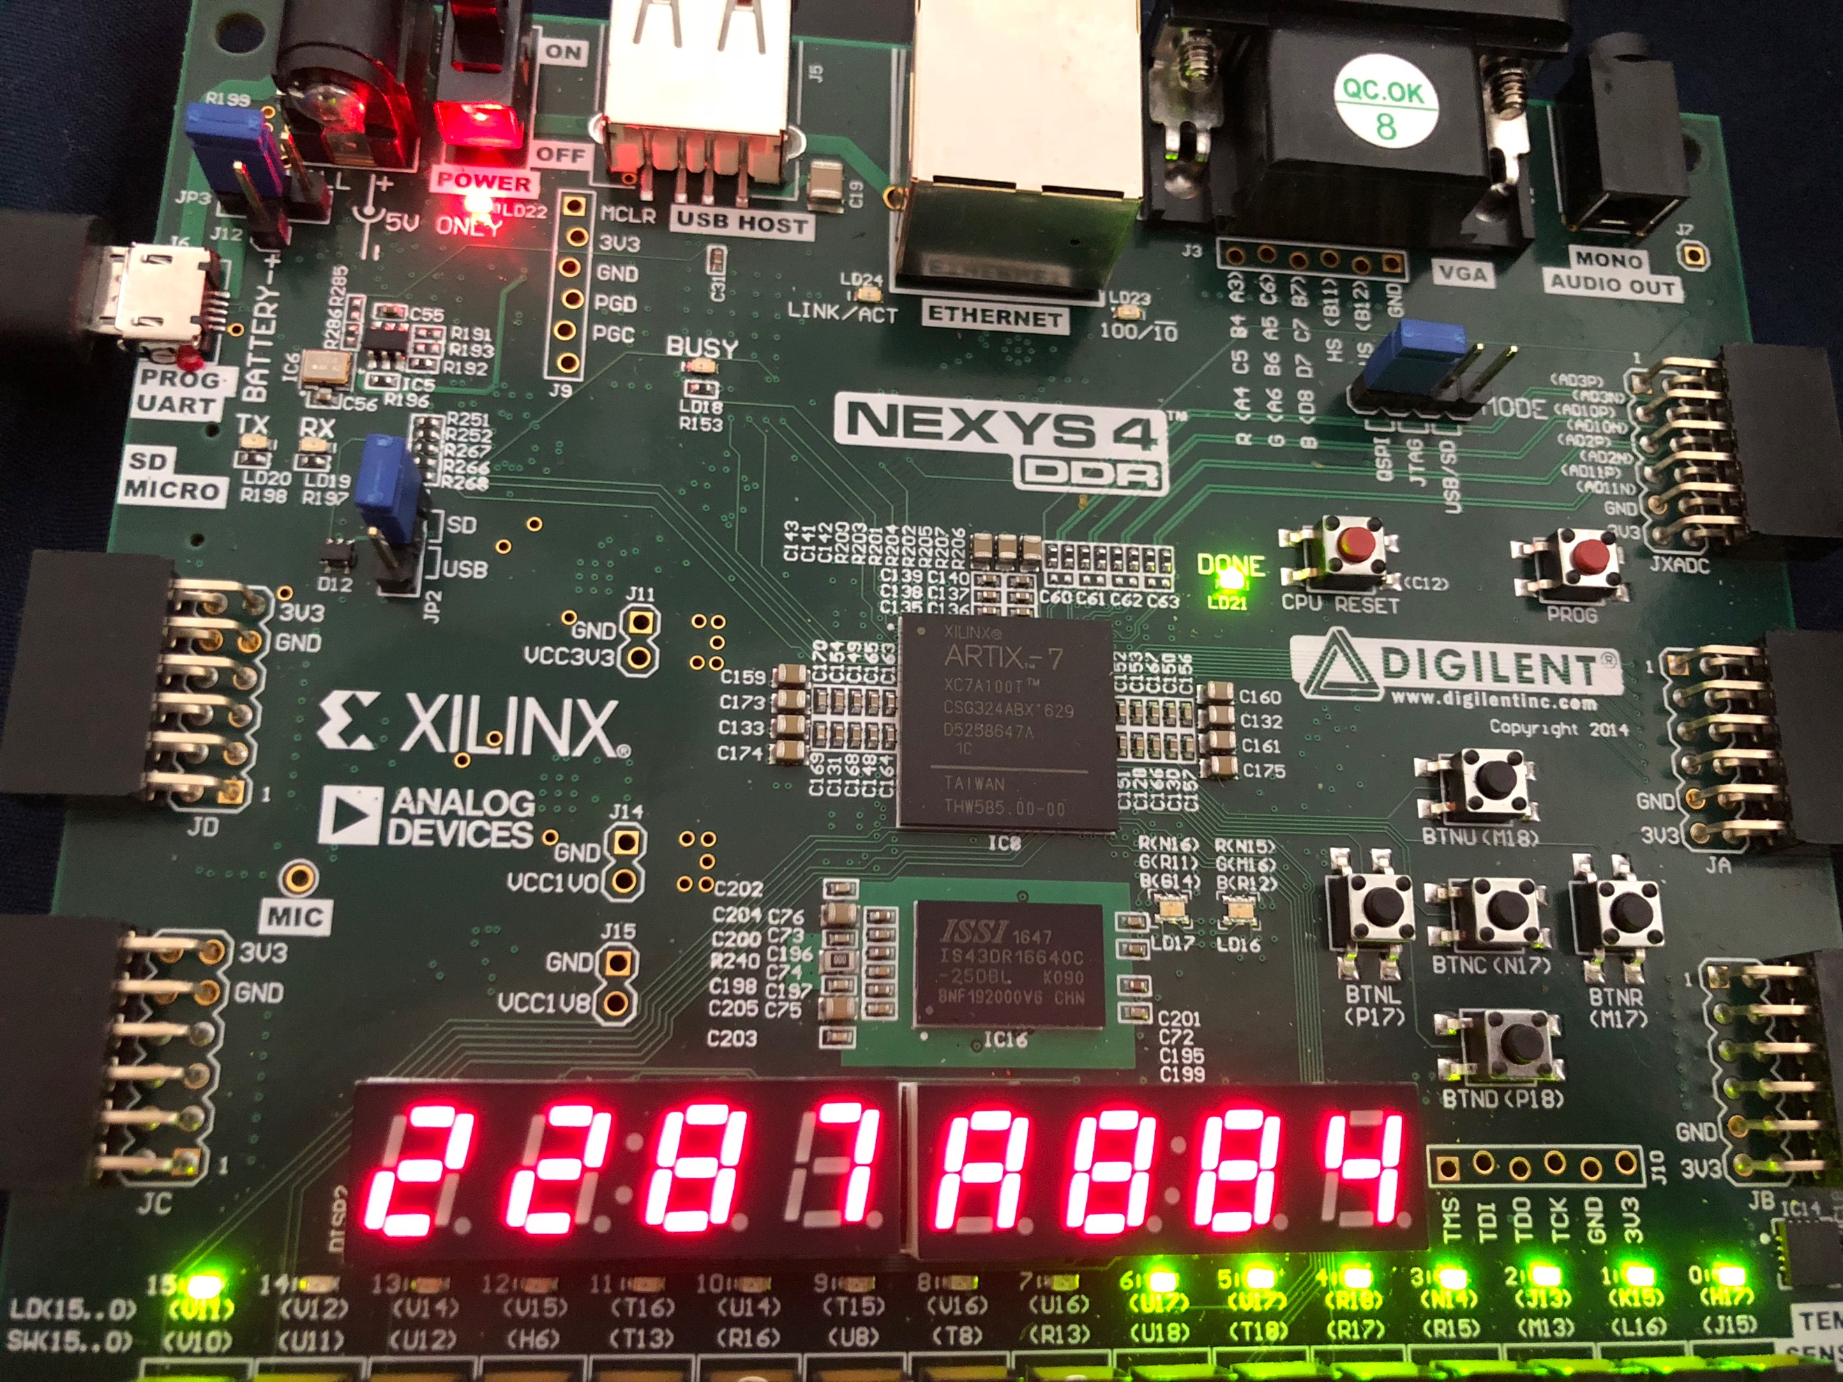

output[31:0]